

CP Lab-12 Tasks

Name: Syed Muhammad Raza Ali

Enrolment: 02-134231-028

Course: CP Lab

Faculty: Miss Fatima

Lab 12 Pointers

Note: The task performed in this lab are menu driven and functions based

**Tasks: 01**

Write a program which takes two strings of at-least 6 characters and changes its contents using pointers.

**Tasks: 02**

Write a program to count the number of elements in a string using pointers.

**Tasks: 03**

Bubble sort a numeric array using a pointer.

* Loop of access each array
* Loop of compare array elements
* Compare two adjacent elements
* Change < to > in descending order.
* Swapping elements if elements are not in intended order.

**Bubble sort Algorithm:**

For i<-1 to indexofLastelemnt -1

If(leftelement>rightelement)

Swap leftelement and rightelement

End

Bubble sort.

Code:

#include <iOStream>

#include <string>

using namespace std;

void swap(string* ptr_a, string* ptr_b) {

cout << "Strings before swapping are : " << endl << *ptr_a << endl << *ptr_b << endl;

string temp;

temp = *ptr_a;

*ptr_a = *ptr_b;

*ptr_b = temp;

cout << "Strings after swapping are : " << endl << *ptr_a << endl << *ptr_b << endl;

}

void bubbleSort(int* arr, int size) {

for (int i = 0; i < size - 1; i++) {

for (int j = 0; j < size - i - 1; j++) {

if (*(arr + j) > *(arr + j + 1)) {

int temp = *(arr + j);

*(arr + j) = *(arr + j + 1);

*(arr + j + 1) = temp;

}

}

}

}

void printArray(int* arr, int size) {

for (int i = 0; i < size; i++) {

cout << *(arr + i) << " ";

}

cout << endl;

}

void print(int* arr, int size) {

for (int i = 0; i < size; i++) {

cout << *(arr + i) << " , ";

}

}

int main() {

char choice;

cout << "Press 1 to perform Task 01" << endl

<< "Press 2 to perform Task 02" << endl

<< "Press 3 to perform Task 02" << endl;

cin >> choice;

if (choice == '1') {

string a, b;

string* ptr_a = &a, * ptr_b = &b;

cout << "Enter a string" << endl;

cin.ignore();

getline(cin, a);

cout << "Enter another string" << endl;

getline(cin, b);

swap(ptr_a, ptr_b);

}

else if (choice == '2') {

string a;

string* ptr_a = &a;

cout << "Enter a string" << endl;

cin.ignore();

getline(cin, *ptr_a);

int b = a.length();

cout << "The length of the entered string is " << b;

}

else if (choice == '3') {

int arr[] = { 64, 34, 25, 12, 22, 11, 90 };

int size = sizeof(arr) / sizeof(arr[0]);

cout << "Original array: ";

printArray(arr, size);

bubbleSort(arr, size);

cout << "Sorted array: ";

printArray(arr, size);

}

}

Output (for task 01):

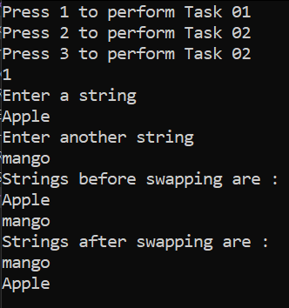

Output (for task 2):

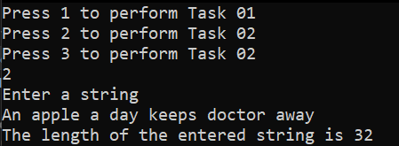

Output (for task 3):

